IDH

Research, teaching and learning about literature, history and the arts in digital ways.

ALLIANCE OF DIGITAL HUMANITIES ORGANISATION

The alliance of digital humanities organization is a digital humanities umbrella organization formed in 2005 to co-ordinate he activities of several regional DH organizations.

BEGINNING

* + Establishment of Centers in 196os, ex. Wisbey founded the Centre for Literary and Lingueistic Computing in Cambridge in 1963
  + First opportunities: IBM organized a conference at Yorktown Heights in 1964
  + Willard McCarty created first Humanist to keep the conversion with people all over the world (I mean western )--it also has a huge role in the Humanities and Computing !
  + 1980s to 1990s- Development of personal computers.

THE ERA OF COMPUTERS

Internet and WWW, and part of academic activity and natural tendency .

In the beginning, the web considered as information retrieval not as a tool for HC. Stated considered as a dissemination tool for both publication and other academic activites.

HUMANITIES COUMPUTING

Humanities computing is [a practice of representation, a form of modeling…, mimicry](https://docs.google.com/presentation/d/1-gO8bJRzv7-swdPszc2rYHTpA16_LnI5yCeiLcaWlzM/edit" \l "slide=next). It is also…[a way of reasoning](https://docs.google.com/presentation/d/1-gO8bJRzv7-swdPszc2rYHTpA16_LnI5yCeiLcaWlzM/edit#slide=id.g2f43661fbf3_2_61) and [a set of ontological commitments](https://docs.google.com/presentation/d/1-gO8bJRzv7-swdPszc2rYHTpA16_LnI5yCeiLcaWlzM/edit#slide=id.g2f43661fbf3_2_73), and [its representational  practice is shaped by the need for efficient computation](https://docs.google.com/presentation/d/1-gO8bJRzv7-swdPszc2rYHTpA16_LnI5yCeiLcaWlzM/edit#slide=id.g2f43661fbf3_2_79) on [the one hand, and for human communication](https://docs.google.com/presentation/d/1-gO8bJRzv7-swdPszc2rYHTpA16_LnI5yCeiLcaWlzM/edit#slide=id.g2f43661fbf3_2_85) on the other

REASONS OF TRANSITIONFROM HUMANITIES COMPUTING TO

DIGITAL HUMANITIES

HC is limited, did not explore much, mostly quantitative, did not invent anything.

* Know how - lack
* basic tools – traditional
* Inclusivity
* Manpower
* No invention
* Lack of exposure
* Strong traditional boundary

METADATA-

Metadata is data about data.

WHY DO WE NEED METADATA? To standardized and categorized.

1. Lack of linking
2. scattered
3. stagnant
4. Lack of community building

ARCHIVES

The collection of items which form evidence of the activites of a person or institution. We saw many archives like archive of William Blake which is known as Blake archive and Dante’s archive.

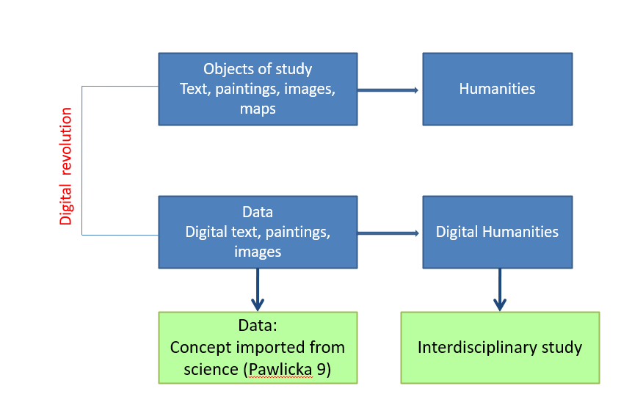

What is data?

Data is a raw collection of information based on facts. Data can be created and manufactured.

Data-

* Information Extracted
* Collection of information
* Facts
* Useable
* Storable
* Experimental
* Raw
* Omnipresent

Smart data-

A data that is machine readable is known as smart data.

Pre Processing-

It stands for cleaning of data.

END.